**CTEC 3350  
Web Communication Design and Development 2**

**Flexbox – flex-wrap: \***

Screenshot 1

Paste a copy of your screenshot including your Student Name and Student ID (here)

Paste the style declaration you used to make your screenshot happen.

display:   
flex-direction:  
flex-wrap:

Screenshot 2

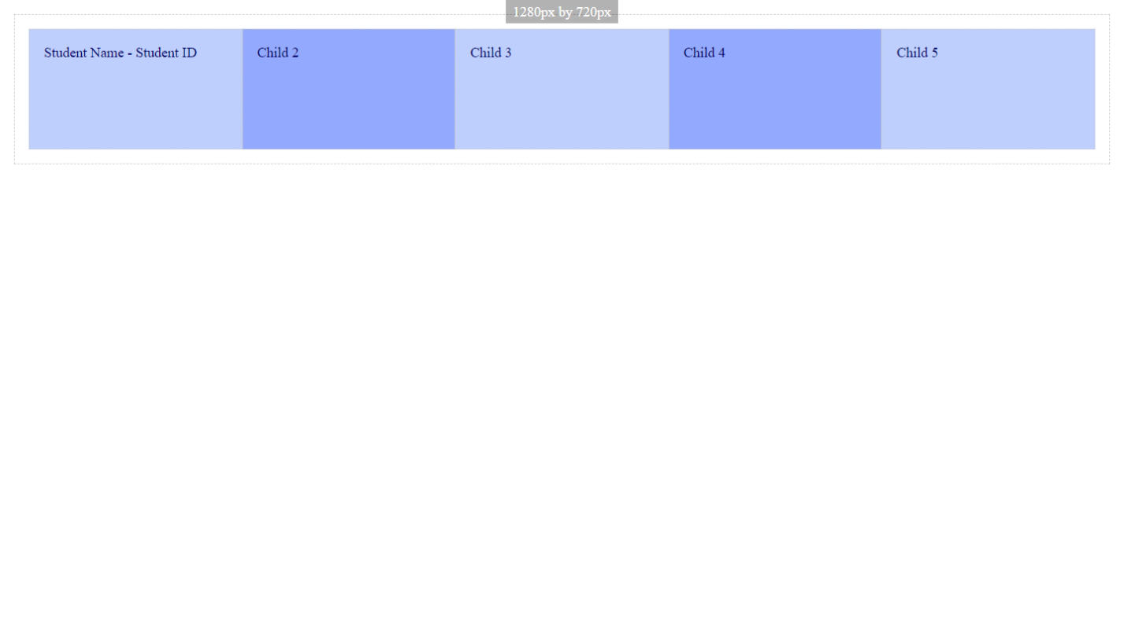

Paste a copy of your screenshot including your Student Name and Student ID (here)

Paste the style declaration you used to make your screenshot happen.

display:   
flex-direction:  
flex-wrap:

Screenshot 3

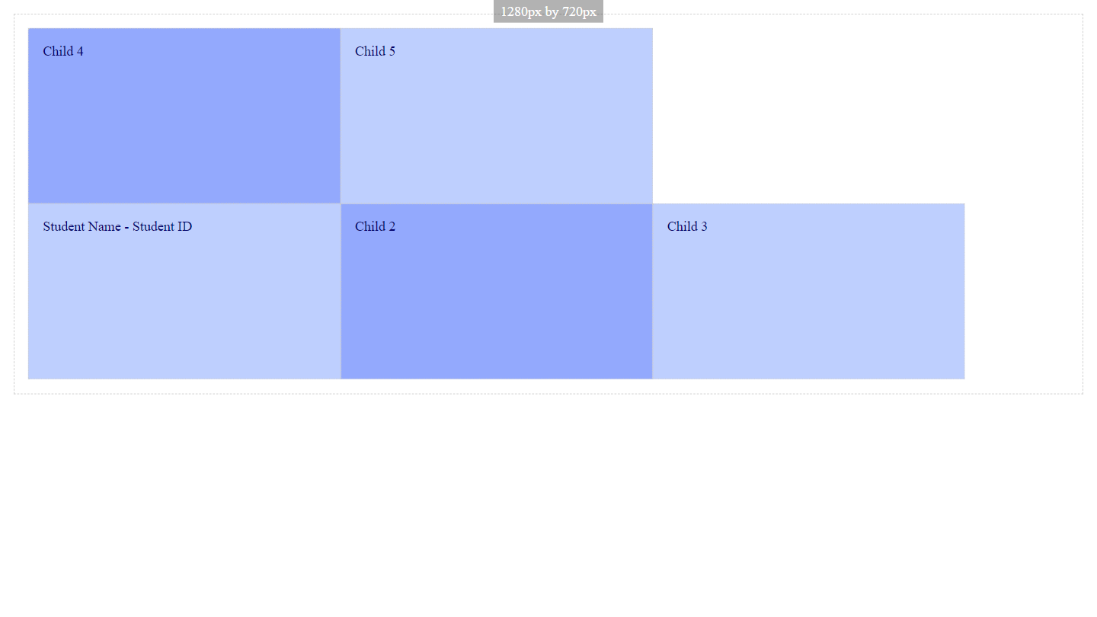

Paste a copy of your screenshot including your Student Name and Student ID (here)

Paste the style declaration you used to make your screenshot happen.

display:   
flex-direction:  
flex-wrap: